ASSIGNMENT 2.3
HT NO:2303A51827
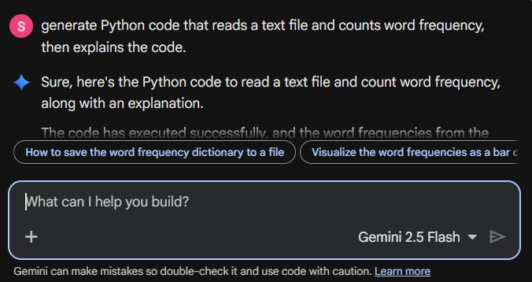

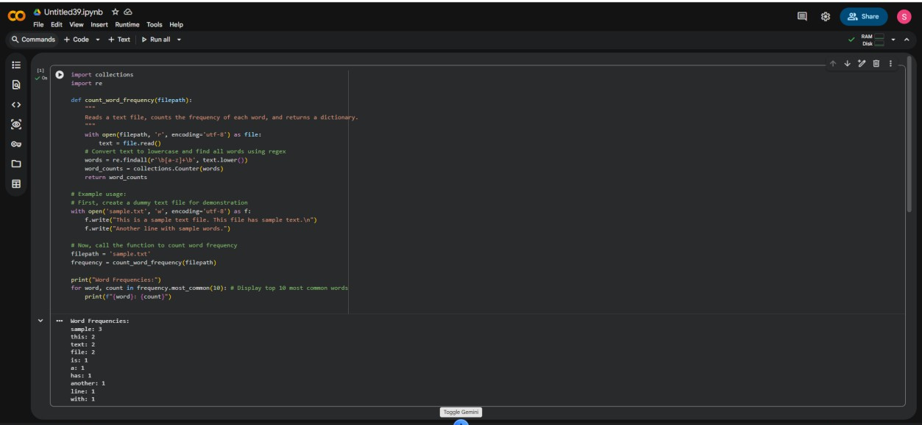
Code Explanation:
This code defines a function count_word_frequency that takes a file path as input and returns a dictionary containing the frequency of each word in the file.

Import collections and re:
  - collections.Counter is used to easily count hashable objects.
  - re (regular expressions) is used to find words in the text.

count_word_frequency(filepath) function:
  - It opens the specified filepath in read mode ('r') with UTF-8 encoding.

  - Reads the entire content of the file into the text variable.
  - text.lower(): Converts all characters in the text to lowercase to ensure that words like "The" and "the" are counted as the same word.
  - re.findall(r'\b[a-z]+\b', ...): Uses a regular expression to find all sequences of one or more lowercase English letters ([a-z]+) that are surrounded by word boundaries (\b). This extracts individual words and ignores punctuation and numbers.
  - collections.Counter(words): Creates a Counter object from the list of
extracted words. The Counter automatically tallies the occurrences of each unique word.
  - Returns the word_counts dictionary.
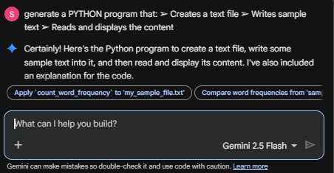

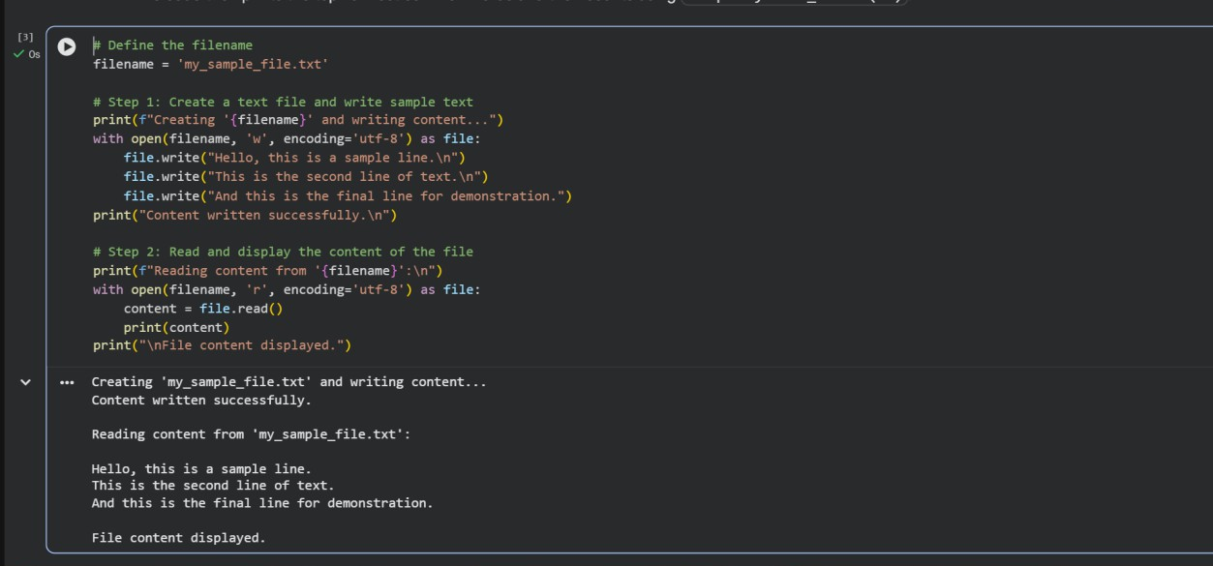
Code Explanation:
This program demonstrates basic file I/O operations in Python:
- filename = 'my_sample_file.txt': Defines the name of the text file that will be created and manipulated.

Writing to the file:
  - with open(filename, 'w', encoding='utf-8') as file:: This line opens the file
named my_sample_file.txt in write mode ('w'). If the file doesn't exist, it will be created. If it does exist, its content will be truncated (emptied) before
writing. encoding='utf-8' ensures proper handling of various characters.
  - The with statement ensures that the file is automatically closed even if errors occur.
  - file.write(...): These lines write the specified string content into the file. The \n character is used to add a new line.

Reading from the file:
  - with open(filename, 'r', encoding='utf-8') as file:: This line opens the same file in read mode ('r').
  - content = file.read(): Reads the entire content of the file and stores it as a single string in the content variable.
  - print(content): Displays the read content to the console.
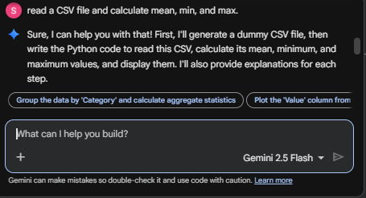
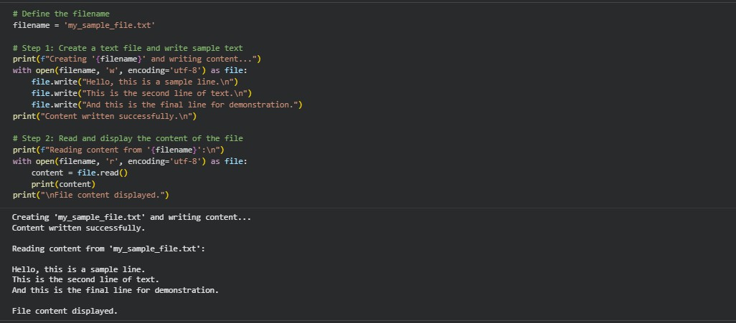

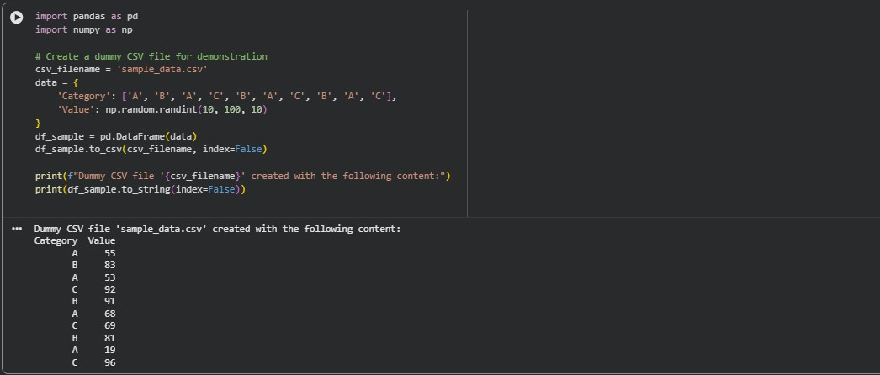
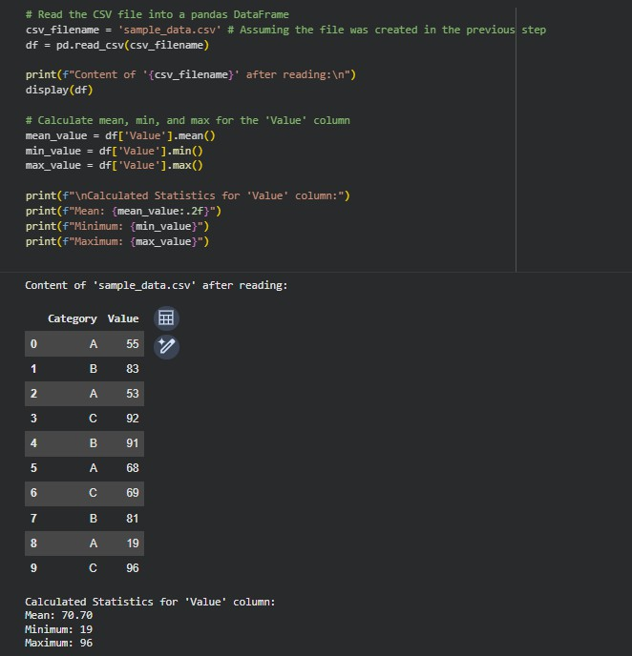
Code Explanation: Reading CSV and Calculating Statistics
This cell reads the previously created CSV file and then calculates the mean, minimum, and maximum values of its 'Value' column.
- csv_filename = 'sample_data.csv': Specifies the name of the CSV file to read.

- df = pd.read_csv(csv_filename): Reads the CSV file into a pandas DataFrame named df.
- display(df): Prints the entire DataFrame to show its content after reading.
- mean_value = df['Value'].mean(): Calculates the average of all values in the 'Value' column.
- min_value = df['Value'].min(): Finds the smallest value in the 'Value' column.
- max_value = df['Value'].max(): Finds the largest value in the 'Value' column.
- Finally, the calculated mean, minimum, and maximum values are printed to the console.
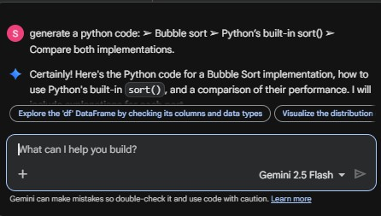
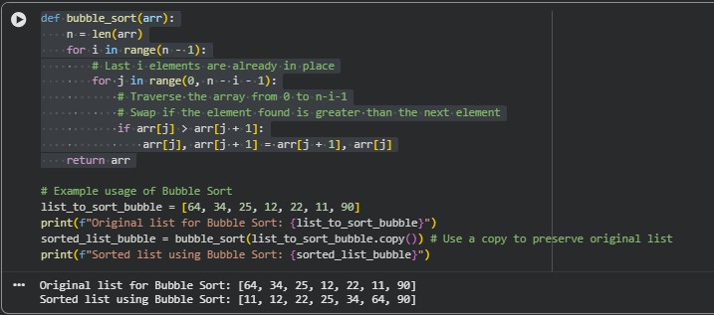
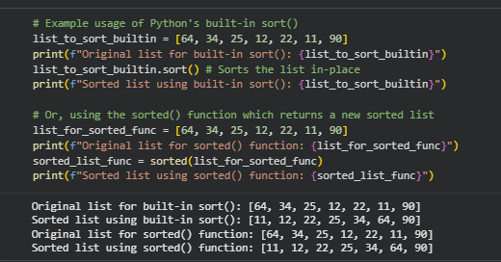

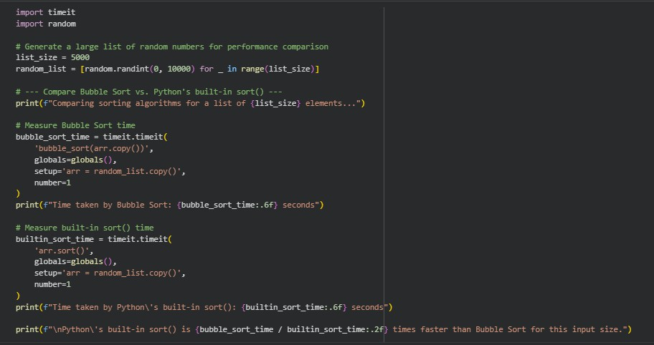
Code Explanation: Comparison of Implementations
This section compares the performance of the bubble_sort function against Python's built- in list.sort() method using the timeit module.
- import timeit and import random: Imports necessary modules. timeit is for precise timing of small code snippets, and random is used to generate test data.
- Generate Test Data: A large list (random_list) of list_size (e.g., 5000) random integers is created. This ensures a meaningful comparison, as the performance difference becomes more apparent with larger datasets.

timeit.timeit():
  - This function measures the execution time of a small piece of Python code.
  - The first argument is the code string to be timed.
  - globals=globals(): Makes sure the bubble_sort function and random_list are available in the scope where timeit runs the code.
  - setup='arr = random_list.copy()': Before each timing run, a fresh copy
of random_listis made and assigned toarr`. This is crucial because both sorting functions modify the list in-place, and we want to sort the same initial data for fair comparison.
  - number=1: Specifies that the code is executed once for timing. For very small
operations, timeit often runs multiple times and takes an average, but for sorting a list of 5000 elements, one run is sufficient.
- Results: The execution times for both bubble_sort and list.sort() are printed. You will typically observe that Python's built-in sort is significantly faster because it uses a highly optimized algorithm (Timsort) which has a much better average and worst-case time complexity (O(n log n)) compared to Bubble Sort (O(n^2)).

